Day 3

Run containers on VM (docker run)

> docker run \
-p 8080:8080 \
-p 5001:5001 \
-e DB_URL="jdbc:postgresql://host.docker.internal:5432/bugtracker" \
-e DB_USERNAME=postgres \
-e DB_PASSWORD=postgres \
-e OPENAI_API_KEY=your-openai-key \
bug-tracking-backend:v1

- docker run -p 5173:80 bug-tracking-frontend:v1

- docker ps

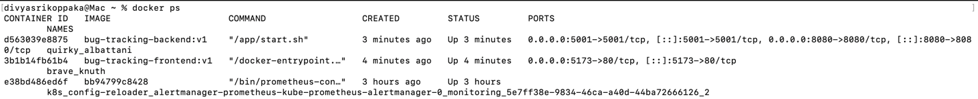

Google cloud: configuration

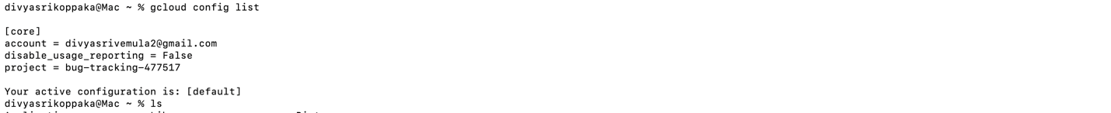

Architecture:

Overall Network Structure
The entire application lives inside a secure VPC (Virtual Private Cloud) named bugtracker-vpc (with an IP range of 10.10.0.0/16). This VPC is divided into two main areas:
- Public Subnet (10.10.1.0/24): This subnet holds the application components that are exposed to traffic (via the load balancer).
- Private Subnet (10.10.2.0/24): This subnet is isolated from the public internet and is used to securely host the database.

➡️ Step-by-Step Traffic Flow
Here is how a user interacts with the bug tracker application:
- User Access: A User (Browser) sends a request (HTTP/HTTPS) to the application.
- Ingress & Routing: This request first hits the Ingress / Load Balancer. This component is responsible for "Routing traffic" to the correct service. It also "Retrieves Artifacts" from the Container Registry (which stores the application's Docker images).
- Frontend (React): The Load Balancer forwards the request to the Frontend Deployment (React Pods). This is the user interface of your bug tracker. It runs as a GKE deployment with 2 replicas for high availability.
- Backend (Spring Boot): The React frontend makes "Backend REST calls" to the GKE Cluster Deployment (Spring Boot Pods). This is the core application logic, also running as a GKE deployment with 2 replicas.
- AI & Data Services: The Spring Boot backend then communicates with two services to get or store data:
  - AI Service: It sends "AI requests" to the AI Service Deployment (FastAPI + LangChain). This service (with 1 replica) is likely used for features like bug triage, suggesting solutions, or processing bug descriptions.
  - Database: It sends "DB JDBC" requests to the Cloud SQL (PostgreSQL) database. This is where all the bug tracking data (users, tickets, comments) is stored.
This architecture securely isolates the database in a Private Subnet, allowing only the Spring Boot backend to access it via its Private IP on port 5432. The application and AI services run in the Public Subnet and are managed by GKE.

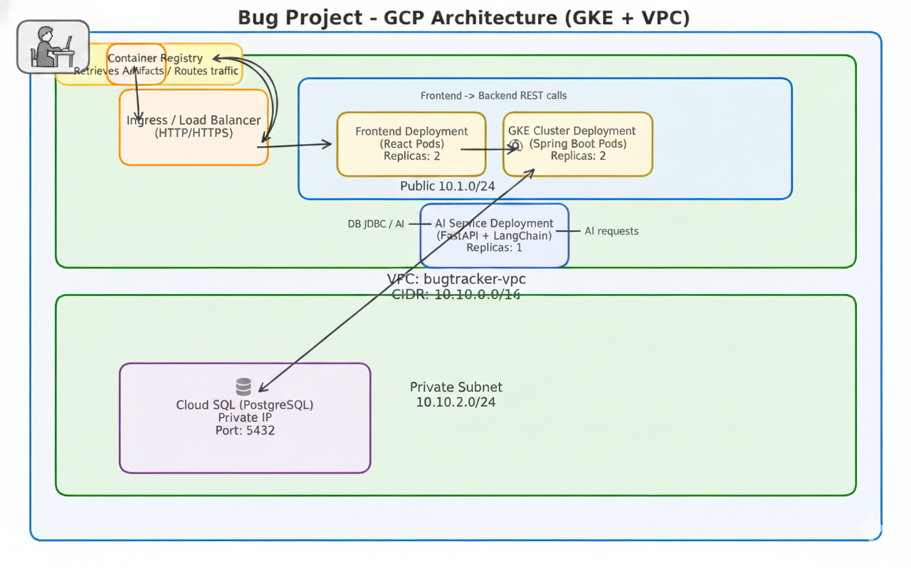
Build infrastructure using Terraform:
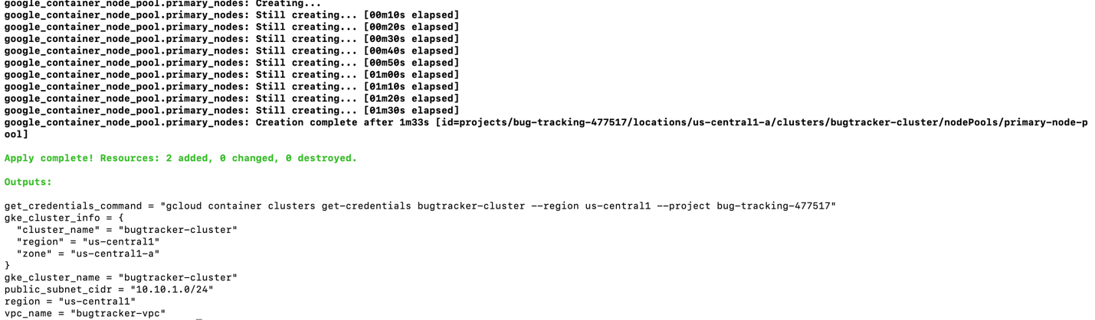
In Gcloud:
- VPC network & subnets
gcloud container clusters describe bugtracker-cluster --region=us-central1-a
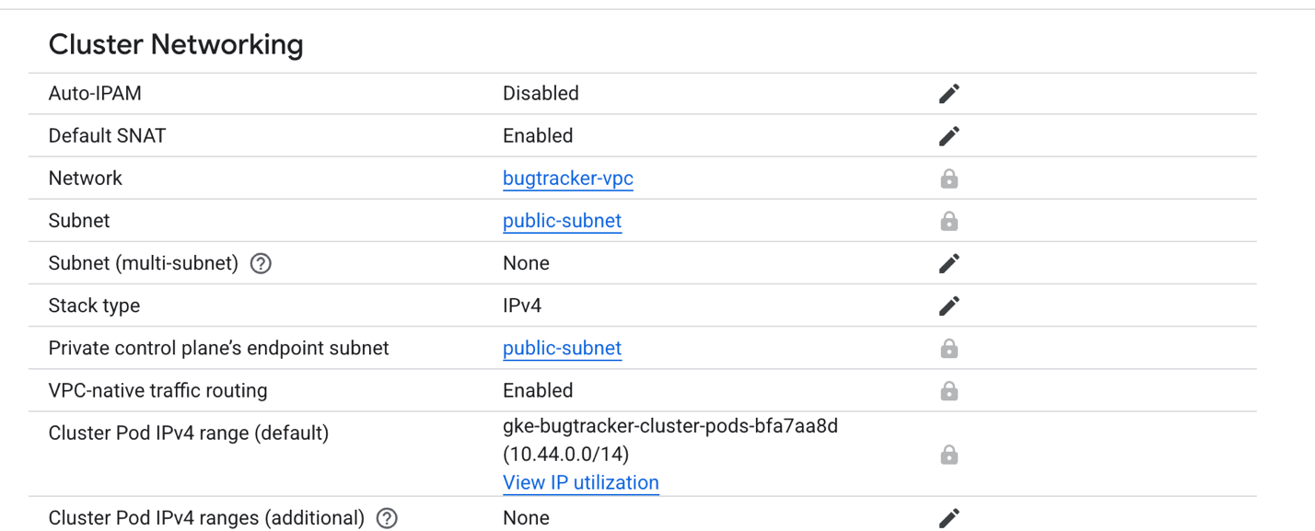
- Firewall rules
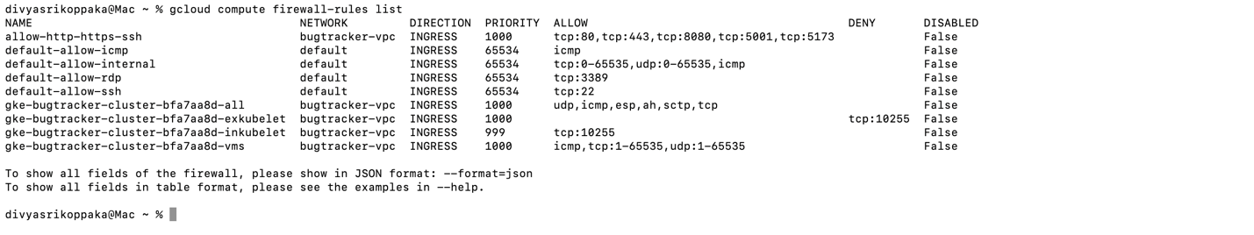
- VM instances
Build & Push Docker Images to GCP Registry
- gcloud artifacts repositories create bug-tracker-repo \
--repository-format=docker \
--location=us-central1 \
--description="Bug tracker images"

- gcloud auth configure-docker us-central1-docker.pkg.dev
- docker tag bug-tracking-backend:v1 us-central1-docker.pkg.dev/bug-tracking-477517/bug-tracker-repo/bug-tracking-backend:v1
- docker tag bug-tracking-frontend:v1 us-central1-docker.pkg.dev/bug-tracking-477517/bug-tracker-repo/bug-tracking-frontend:v1
- docker push us-central1-docker.pkg.dev/bug-tracking-477517/bug-tracker-repo/bug-tracking-backend:v1

- docker push us-central1-docker.pkg.dev/bug-tracking-477517/bug-tracker-repo/bug-tracking-frontend:v1

Kubernetes manifests to use our current ports:
- deployment_backend.yaml: exposes the combined Spring Boot + AI container on ports 8080 and 5001 (both in the pod spec and the ClusterIP service).
- deployment_frontend.yaml: aligns the React nginx image to port 80 internally and via the LoadBalancer service.

Final:
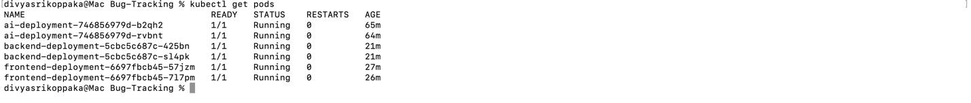

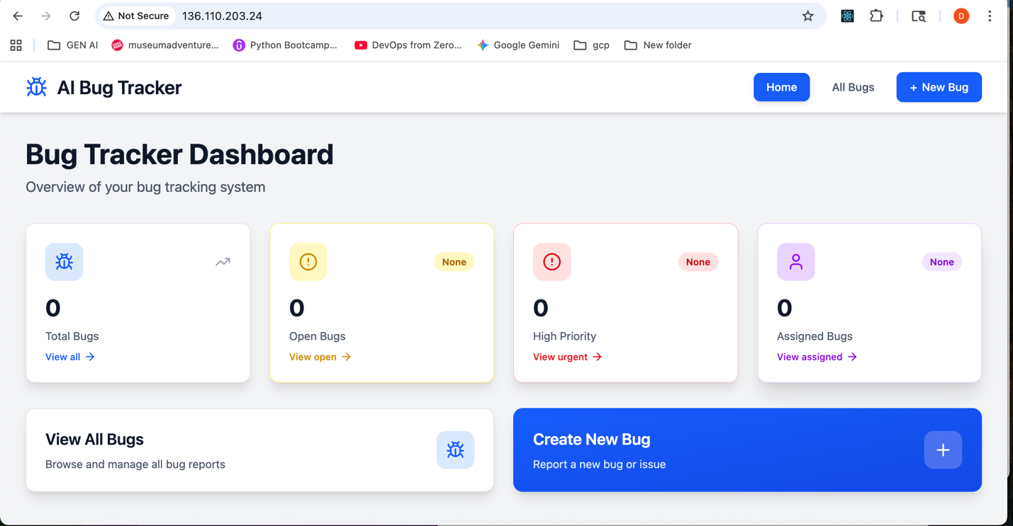

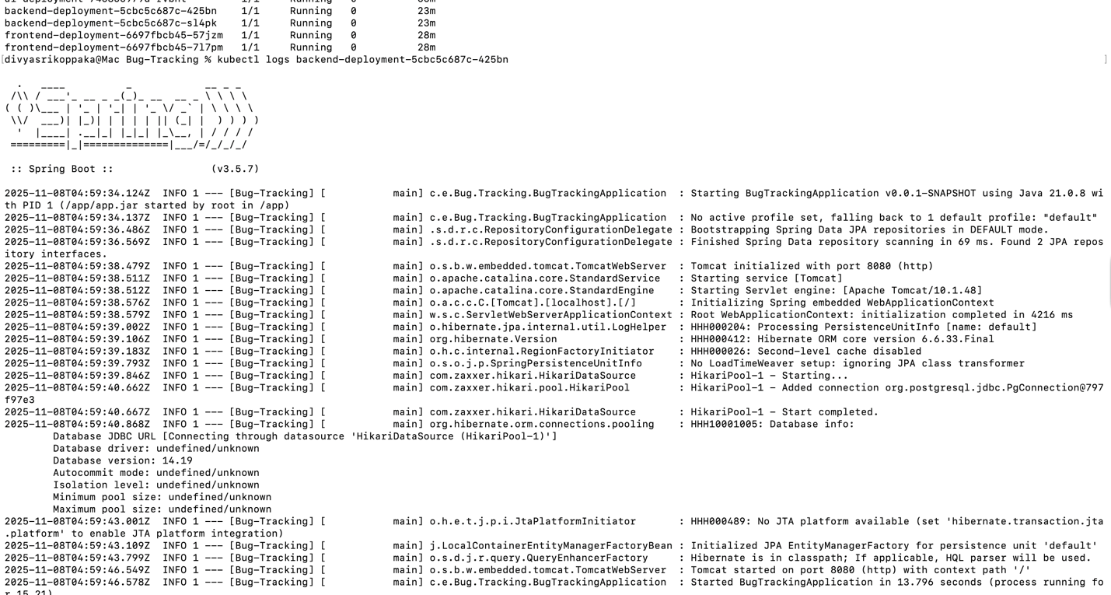
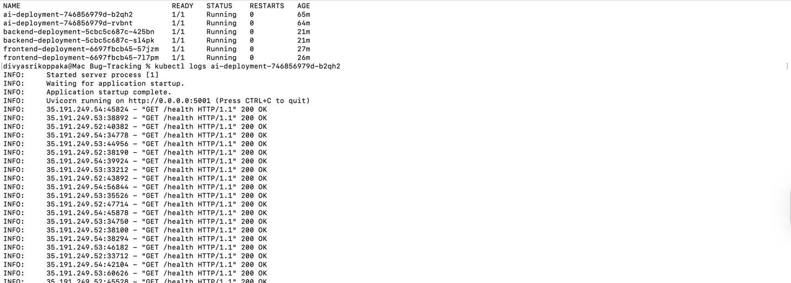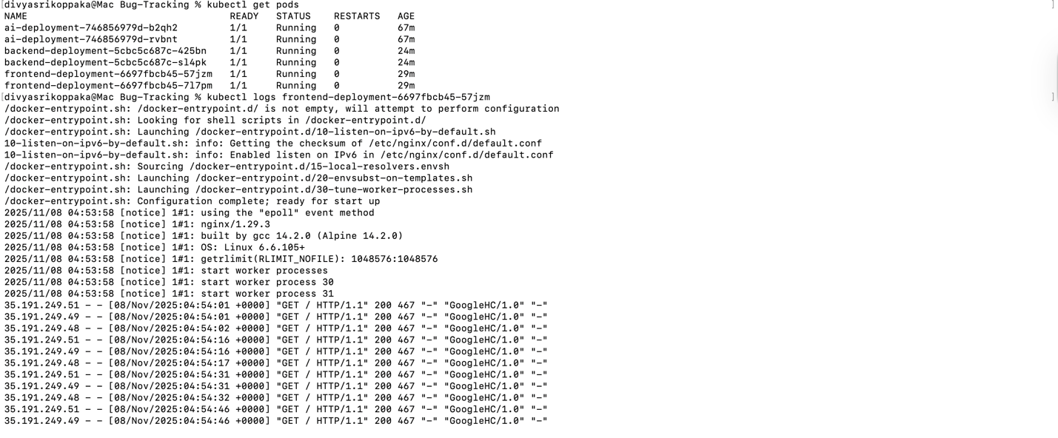
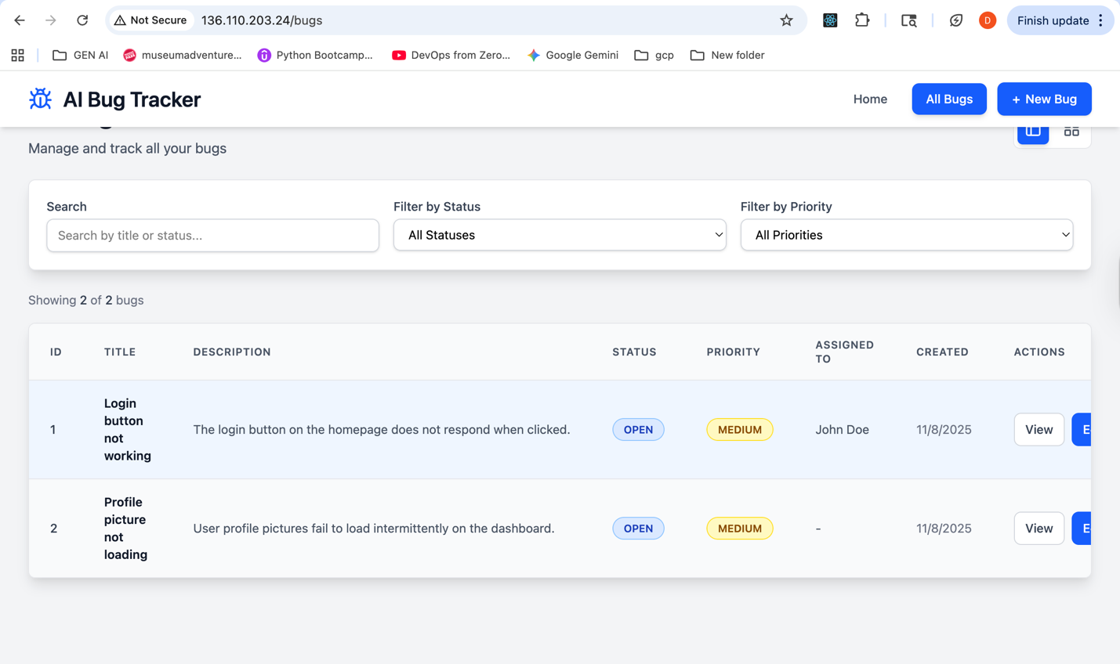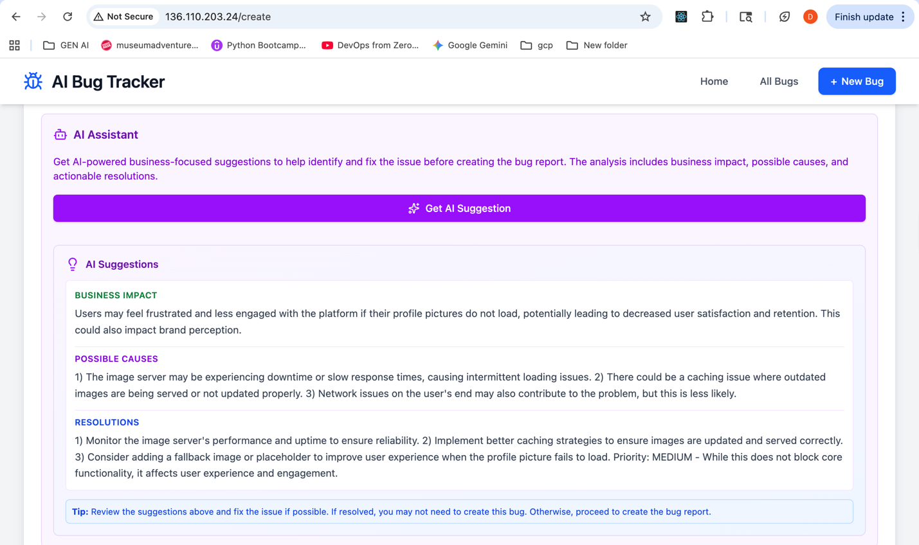

Overview:
- Provisioned a GCP VPC with public/private subnets, firewall rules, and a zonal GKE cluster via Terraform.
- Added private service connect peering and a Cloud SQL for PostgreSQL instance (DB, user, password managed by Terraform).
- Terraform now syncs a Kubernetes secret (backend-db-credentials) containing the Cloud SQL JDBC URL and credentials.
- Built and pushed new backend image (v4) exposing /api/ endpoints and health checks; deployed as a GKE Deployment.
- Built and pushed new AI service image (v2) with simplified health response; deployed alongside a BackendConfig for HTTP health probes.
- Built and pushed frontend image (v3) that reads VITE_API_BASE_URL and calls the backend through /api.
- Created separate services.yaml defining ClusterIP services for frontend, backend, and AI, each referencing appropriate BackendConfigs.
- Configured a GCE Ingress routing / to frontend, /api/* to the backend, and /ai/* to the AI service, with health checks now reporting healthy.
- Verified Cloud SQL connectivity by querying the employees table from a temporary pod; backend startup logs confirm successful DB connection.
- Tested ingress endpoints (/api/employees, /ai/suggest) to ensure the full stack is reachable through the public load balancer.

